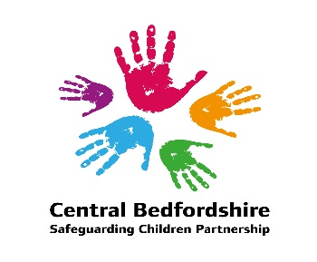

Central Bedfordshire Safeguarding Children Partnership
Multi Agency Safeguarding Arrangements

(June 2023)

Name of arrangements: Central Bedfordshire Safeguarding Children Partnership
Details of how partners will work together to improve the outcomes for children and families are contained within Appendix A – the Terms of Reference for the Central Bedfordshire Safeguarding Children Strategic Board.

Geographical Area covered by arrangements: Central Bedfordshire

Local Safeguarding Partner Agencies: Further details around the accountability of these partners can be found in Appendix A.
- Central Bedfordshire Council
- Bedfordshire, Luton & Milton Keynes Integrated Care Board (BLMK ICB)
- Bedfordshire Police

Principles of the Partnership: Strong effective multiagency safeguarding arrangements do not just happen; they demand an active commitment to collaboration and a common purpose. Effective protection of children and the promotion of their wellbeing can only be secured through working together. Safeguarding arrangements for the children and young people being built, sustained, tested and continuously improved.

The key principles of the safeguarding arrangements are:
- Safeguard the rights of all children consistently across the county but not losing the focus on the needs of Central Bedfordshire children and young people.
- That all partners keep the child in focus when making decisions about their lives and work in partnership with them and their families.
- All partners champion a continuous cycle of learning, to further develop service provision and delivery to support the child and their family.
- Duty to co-operate on all partners, particularly schools.
- Independent challenge, authority and resource to fulfil both statutory functions & ensure learning.
- That any change is not led by austerity or efficiencies but by measurable improvements in the safeguarding system that benefit children and families.

Governance: The Governance for the multi-agency safeguarding arrangements sits with the 3 Multi-agency Safeguarding Partners and sits within their internal governance structures:
- Local Authority – Central Bedfordshire Executive Committee
- Bedfordshire, Luton & Milton Keynes Integrated Care Board – ICB Governing Board
- Bedfordshire Police – The PEEL Board

Reporting: In order to bring about transparency the Central Bedfordshire Multi Agency Safeguarding Arrangements will publish a report at least every 12 months which sets out what has been done as a result of the arrangements and will include information on child safeguarding practice reviews. The report will also include:
- Evidence of the impact the Multi-Agency Safeguarding Arrangements have had, including information about training and the outcomes for children and families from early help to looked after children and care leavers.
- An analysis of any areas where there has been little or no evidence of progress on agreed priorities.
- A record of decisions and actions taken by the partners in the report's period (or planned to be taken) to implement the recommendations of any local and national child safeguarding practice reviews, including any resulting improvements.
- Ways in which partners have sought and utilised feedback from children and families to inform their work and influence service provision.

The report will be published on the Safeguarding Partnership website and a copy will also be sent to the National child Safeguarding Practice Review Panel and the What Works Centre for Children's Social Care within 7 working days of being published.

Arrangements for Independent Scrutiny: The Central Bedfordshire Multi Agency Safeguarding Arrangements are chaired and scrutinised by an independent appointment. It has been agreed by the three multi-agency safeguarding partners that it is the responsibility of the Chief Executive (Head of Paid Service) of the Local Authority to appoint or remove the Independent Chair with the agreement of the other two safeguarding partners. The Chief Executive, drawing on the other multi-agency partners, will hold the chair to account for the effective working of the Multi Agency Safeguarding Arrangements.

The Independent Chair is responsible for scrutinising and challenging local partners and considering how effectively the safeguarding arrangements are working for children, families and practitioners and how well are the safeguarding partners providing strong leadership. The role is objective and acts as a critical friend and promotes reflection and drives continuous improvement. Arrangements for this post are compliant with Working Together 2018.

The Central Bedfordshire Case Review Group which is responsible for taking forward local Child Safeguarding Practice Reviews is also chaired by the Independent Chair/Scrutineer.

The Pan Bedfordshire Co-ordinating Group which is responsible for overseeing the work of the Pan Bedfordshire Sub-Groups is chaired by one of the three Bedfordshire Safeguarding Children Partnership Independent Chairs/Scrutineers and is rotated on an annual basis.

Details of Arrangements: The Central Bedfordshire Multi-Agency Safeguarding arrangements consist of a Central Bedfordshire Strategic Board and several other Central Bedfordshire focused Sub-groups. The structure also has an overarching wider Pan Bedfordshire Strategic Leaders Group and several Pan Bedfordshire sub-groups. (These Pan Bedfordshire groups cover the local authority areas of Central Bedfordshire, Bedford and Luton and ensure strategic decision making is joined up across Bedfordshire and also helps to avoid duplication for partners). A copy of the MASA Structure is provided below:

Central Bedfordshire Multi Agency Safeguarding Arrangements Structure Chart:

3

Relevant Agencies: The relevant agencies of the Multi Agency Safeguarding Arrangements are listed below. All the listed partners have a role to play in safeguarding children and young people across Central / Bedfordshire. The arrangements are working well with all partners committed to the safeguarding of children in Central Bedfordshire. The Central Bedfordshire Safeguarding Children Partnership will continue to review its relevant agencies on an annual basis as part of its Development Day.

- Independent Chair/Scrutineer
- CAFCASS (Children and Family Courts Advisory and Support Service)
- Bedfordshire, Luton and Milton Keynes Integrated Care Board.
- Local Authority, including Adult Services, Children's Services and Public Health
- Bedfordshire Youth Offending Service
- Bedfordshire Police
- Bedfordshire NHS Hospitals Foundation Trust
- Bedfordshire Probation Service
- National Probation Service
- 1 lay member
- NHS England (via the ICB)
- Education Settings, including schools and the local college.
- East London Foundation Trust
- Cambridgeshire Community Services NHS Trust
- Representation from the Voluntary Sector (Voluntary Organisations for Children, young people & families, VOCypf and Central Bedfordshire Home-start)

Links to Early Years and Education Settings:
Currently on our Central Bedfordshire Strategic Board Meeting we have representatives from the Local Authority School Improvement Team along with senior representatives from a local secondary school, primary school and college. Officers from the Local Authority School Improvement Team also sit on the Central Bedfordshire Case Review Group and Performance Groups.

In addition, there is a Pan Bedfordshire Safeguarding in Education Sub-group that is chaired by the 3 Bedfordshire Local Authority Chief Officers for Education (on a rotating basis) and has representatives from schools across Bedfordshire. The purpose of the group is:
The Pan Bedfordshire Safeguarding Education Group is a strategic group, tasked to bring education as the fourth safeguarding partner and reporting directly to the Pan Bedfordshire Coordinating Group. It will ensure that the voice of the education sector within Bedfordshire is heard and represented across Bedford Borough, Central Bedfordshire, and Luton Safeguarding Children Partnership structures, building a shared understanding of priorities.

The Pan Bedfordshire Safeguarding Education Group will actively work with the three Safeguarding Children Partnerships to perform their duties in safeguarding by monitoring safeguarding activities across the county to improve outcomes for children and young people.

This group provides a communication channel between education settings, including Governors, local Designated Safeguarding Lead forums and the three Safeguarding Children Partnerships. It provides support and Governance to the local cluster/ hub arrangements as they share themes, challenges, and good practice in their safeguarding work.

There is a dedicated section of the regular Schools Designated Leads (DSL) Forum, where schools can raise issues or information that they would like feedback to the Safeguarding in Education Group.

The Business Manager of the Safeguarding Children’s Partnership attends the DSL forum on a regular basis to provide updates on behalf of the partnership, and Local schools and colleges are invited to take part in audits and case reviews where they are relevant.

The Safeguarding Children Board also communicates with schools via its own newsletter and also a local newsletter dedicated for schools.

Links to Youth Custody and Residential Homes: There are no Youth Custody establishments located in Central Bedfordshire (or Bedfordshire) however a number of young people from Central Bedfordshire are placed in Juvenile Secure Custody across England and Wales. The manager of Bedfordshire Youth Offending Service is a member of the Central Bedfordshire Multi-Agency Safeguarding Arrangements.
In relation to residential homes, private children's homes and 16+ units, the Assistant Director for Safeguarding and Early Help who is responsible for the Corporate Parenting/ Looked After Children's Service is a member of the Central Bedfordshire Multi-Agency Safeguarding Arrangements.

Within Central Bedfordshire the Quality Assurance Manager organises regular forums throughout the year with the local residential homes and 16+ providers which the safeguarding arrangements/the board use as a link to local residential homes when needed.

Voice of Children and Families: The voice of children and young people is a golden thread throughout our work, overseen by the Pan Bedfordshire Coordinating Group.

In addition:
- All board reports are asked to consider the voice of the child.
- All audits consider the voice of the child(ren) and families.
- Families are always contacted to participate in local Child Safeguarding Practice Reviews.

A Child Centred Approach to Safeguarding: A child centred approach is fundamental to safeguarding and promoting the welfare of every child. A child centred approach means keeping the child in focus when making decisions about their lives and working in partnership with them & their families. All practitioners should follow the principles of the Children Act 1989 and 2004 that states that the welfare of the child is paramount and that they are best looked after within their families, with their parents playing a full part in their lives, unless compulsory intervention in family life is necessary.

Children may be vulnerable to neglect and abuse or exploitation from within their family and from individuals they come across in their daily lives. These threats can take a variety of different forms, including sexual, physical and emotional abuse; neglect; exploitation by criminal gangs and organised crime groups; trafficking; online abuse; sexual exploitation and the influences of extremism leading to radicalisation. Whatever the form of abuse or neglect, practitioners should put the needs of the child first when determining what action to take.
Children are clear about what they want from effective safeguarding systems:

- Everyone who works with children has a responsibility for keeping them safe. Everyone who comes into contact with them has a role to play in identifying concerns; sharing information and taking promote action.
- In order that organisations, agencies and practitioners collaborate effectively, it is vital that everyone works with child and families, including those who work with parents/carers, understand the role they should play and the role they should play and the role of other practitioners. They should be aware of, and comply with, this document and associated Pan Bedfordshire Interagency Procedures.

There is no age limit on the right of the child or young person to express their views freely. All children and young people, including those of pre-school age, school age and those who have left full-time education, have a right to be heard in all matters affecting them, their views being given due weight in accordance with their age and maturity.

As mentioned already, the voice and lived experiences of children and young people is a golden thread running through the work of the Central Bedfordshire Safeguarding Partnerships and all its subgroups.

Professional Practice Guidance: All partners will continue to follow the existing Pan Bedfordshire Interagency Procedures. These will underpin the expected standardised process and practice across Bedfordshire. Adoption of these procedures will provide consistency to practitioners who are already familiar with these procedures.

Arrangements for disseminating and embedding Learning from Child Safeguarding Practice Reviews and Multi Agency Audits: The Central Bedfordshire Multi Agency Safeguarding Arrangements has in place a Learning and Improvement Framework to help set out a process for continuously improving practice via the learning loop (shown below).

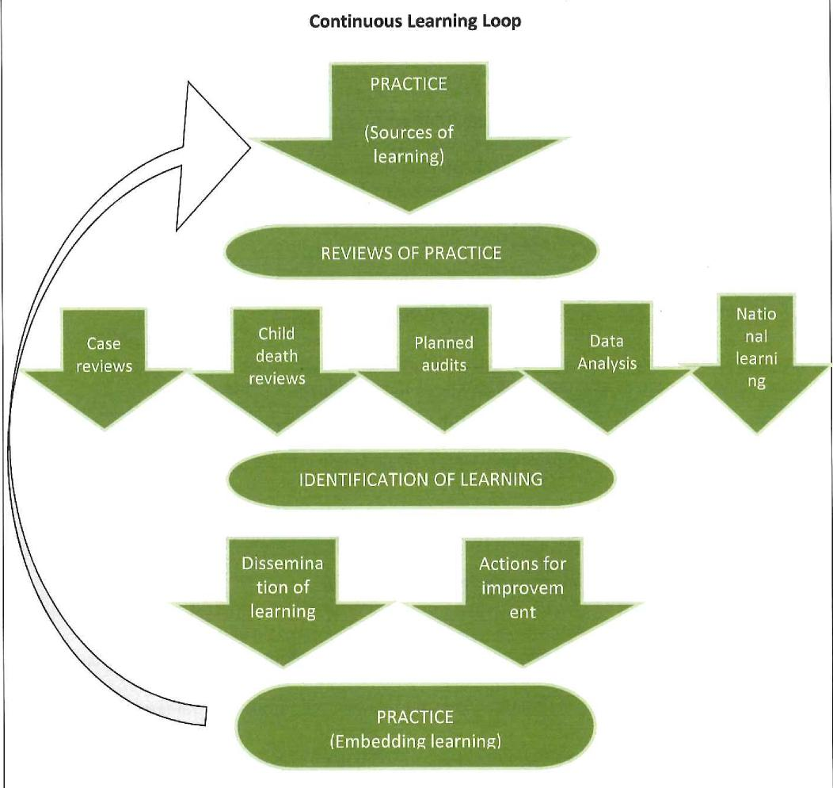

Learning from the above activities (case reviews and audits) are disseminated using a range of methods including:

- Briefings and conferences
- Multi-Agency Training Programme
- Newsletters and briefing documents
- Via the website
- Published Case Reviews
- Single agency training and briefing

Arrangements for commissioning Child Safeguarding Practice Reviews: Appendix B provides details of the Central Bedfordshire process for receiving serious incident notifications and considering and commissioning Child Safeguarding Practice Reviews.

Performance Monitoring Arrangements: The Central Bedfordshire Safeguarding Arrangements have in place a multi-agency performance framework which is monitored and scrutinised by Central Bedfordshire Performance Group on a quarterly basis. Information is reported up to the Central Bedfordshire Strategic Board via an update report at its quarterly board meeting. In addition, performance indicators linked to themes/ priority areas are also developed by the priority area sub-groups for discussion and scrutiny within the individual sub-groups.

Arrangements for Inter-Agency Training: (Including commissioning, delivery, evaluation and monitoring the impact).
Multi agency training across Bedfordshire is organised and commissioned via Safeguarding Bedfordshire, our Pan Bedfordshire Training Unit funded by the three local area Multi Agency Safeguarding Arrangements.

Training: The Pan Bedfordshire Co-ordinating Group via task groups is responsible for the following in relation to training activities:
- processes in place to identify the multi-agency training and development needs of staff and volunteers in Bedfordshire.
- building on the current joint training and development strategy.
- ensuring that the content of the LSCB training programme is based on latest research/clinical evidence about 'what works' when working with children, young people and families.
- ensuring lessons from Child Safeguarding Practice Reviews, other reviews and audits are disseminated with a view to embed into practice.
- overseeing the commission arrangements and ensure relevant and competent trainers are utilised with a broader range of skills.
- monitoring and evaluating the quality and impact of training on practice development and take appropriate & timely action.

Commissioning: External expertise is commissioned where required to ensure the quality of learning/ training. Expertise from across Bedfordshire services is also drawn upon where available to support the learning/ training programme.

Evaluation and impact of training on practice development: We aim to provide each Partnership with a robust approach to evaluating the learning/training delivered through Safeguarding Bedfordshire, measuring both the quality of the training delivered and to evidence the impact on practice development. More information in relation to the training processes are contained in Appendix C

Arrangements for undertaking Multi-Agency Audits: The Multi-agency Safeguarding Arrangements have in place processes to carry out the following activities related to multi-agency audits:
- Development and implementation of a Learning and Improvement Framework.
- Developing and agreeing an annual programme of multi-agency audits.
- Reviewing safeguarding related audits completed by single agencies.
- Ensuring learning from Child Safeguarding Practice Reviews and audits are fed in to training and policies and procedures.
- Ensuring actions from multi-agency audits are implemented and where possible outcomes are measured.
- Sharing up to date knowledge of relevant research findings.

Funding Arrangements:
Current funding arrangements (Per year)

Agency | Amount
Central Bedfordshire Council | £94,222
BLMK ICB | £44,905
Bedfordshire Police | £16,373
Bedfordshire Probation | £2,200
Totals | £157,700

Further funding is provided for the training arrangements.
Threshold Guidance: Central Bedfordshire has Multi Agency Assessment and Threshold Guidance related to the thresholds of needs for children and young people.

This guidance is designed for anyone working with children & young people and their families:
- To show the criteria for access to services for children based on a multi-agency needs/risk matrix.
- To outline the four levels of prevention, need and risk, including safeguarding thresholds.
- To set out the key principles for service provision to children, young people, and families
- To know what action to take if they are worried about a child's welfare or safety.
- To understand what will happen if a child is referred to children's social care.
- To outline the threshold between Early Help and Children's Social Care, although in some circumstances both services will be involved.

Dispute Resolution: Safeguarding partners will work together locally to resolve any disputes using the Pan Bedfordshire Escalation Process. The local safeguarding partners will also be able to discuss and resolve local disputes through the Pan Bedfordshire Strategic Leaders of Children's Services Board.

If the Central Bedfordshire Safeguarding Children's Board receives any complaints that fall outside of the Pan Bedfordshire 'Complaints arising from Child Protection Conferences' procedure, then the complaint will be forwarded to the appropriate agency and copied to their complaints departments. A request will be made for the Safeguarding Board to be kept informed of the status of the complaint and the outcome when resolved.

Child Death Overview Process (CDOP): As per Working Together 2018 our Child Death Review Partners are Bedford Borough Council, Central Bedfordshire Council, Luton Borough Council and Bedfordshire, Luton and Milton Keynes Integrated Care Board. The statutory requirements and responsibilities for child death review partners are set out in Working Together 2018 (page 95 -97).

Bedfordshire and Luton CDOP will produce an annual report for child death review partners on local patterns and trends in child deaths, any lessons learnt, and actions taken, and the effectiveness of the wider child death review process in order to assist child death review partners to prepare their report.

When writing their Annual Report, Bedfordshire and Luton CDOP, in liaison with Milton Keynes CDOP, will consider whether there are any common themes and learning from the year and undertake joint communication campaigns across Bedfordshire, Luton and Milton Keynes. This reflects the wider footprint and the Integrated Care System (ICS) across Bedfordshire Luton and Milton Keynes (BLMK) which includes the BLMK Commissioning Collaborative.

Following Working Together 2018, the Child Death Overview Panel process no longer forms part of the Multi Agency Safeguarding Arrangements, however locally, our processes ensure reporting arrangements between the CDOP and the Central Bedfordshire Safeguarding Children Partnership are in place along with arrangements by which the CDOP will be able to refer cases to the Central Bedfordshire Safeguarding Children Partnership for consideration of a Child Safeguarding Practice Review.

Signatures:

Sarah-Jane Smedmor
Director of Children's Services, Central Bedfordshire Council
Date: 27/05/2023

Sarah Stanley
Associate Director for Quality Safeguarding, BLMK Integrated Care Board
Date: 22/05/2023

Sharn Basra
Assistant Chief Constable, Bedfordshire Police
Date: 26/05/2023

